AAT: A double whammy for leukemia
Nov. 16, 2014
SHL Frost
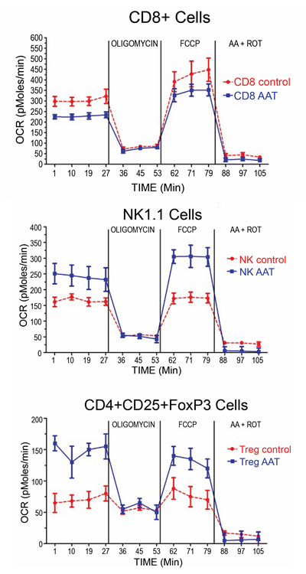
Effect of α-1-antitrypsin (AAT) on oxygen consumption: Ex-vivo oxygen consumption rate (OCR) in CD8+, NK1.1+, and CD4+ CD4+CD25+ FoxP3+ cells from stem cell donors treated with AAT or with albumin (control).
Image provided by Dr. Mario Marcondes
Allogeneic hematopoietic stem cell transplantation (HCT) is a common procedure with a good track record for treatment of leukemia and other blood cancers. Stem cells are taken from a donor with closely matching tissue type (e.g. a sibling or parent) and administered to the patient, and if the transplant engrafts in the recipient's bone marrow the healthy cells will soon start to produce immune cells from the donor stem cells. Any malignant cells that linger after pre-transplant treatment can thus be killed off by the new immune cells, in a process that is referred to as the graft-versus-leukemia (GVL) effect. This is a recognized benefit of allogeneic transplants, but there are unfortunately disadvantages as well. The patient's healthy cells can also be attacked, which is called graft-versus-host disease (GVHD), a complication that can range from mild to life-threatening.
In a recent publication in Blood, Drs. Mario Marcondes, David Hockenbery and Joachim Deeg from Fred Hutch's Clinical Research Division presented a new strategy to prevent acute GVHD, showing that a well-tolerated treatment used for α-1-antitrypsin (AAT) deficiency-related emphysema provided a doubly positive effect when administered to stem cell donors for HCT. AAT is a type of protein called serine protease inhibitor that affects a number of functions, including cell signaling, metabolic reactions within the cells, and cell-mediated immunity. Indications that AAT exposure of donor cells could lower the incidence of GVHD had been previously reported, but concerns were raised that the desired anti-cancer effect could be negatively affected in parallel.
The Fred Hutch investigators showed first, in retrospective analyses on plasma samples from 111 allogeneic transplant donors and their recipients, an inverse relationship between donor AAT levels and the development of GVHD in the transplanted patients. The mechanism was presumably mediated by the AAT-exposed donor cells; therefore, further studies were executed in mouse models. Transplants were performed after AAT treatment of donors and/or recipients with varying levels of histocompatibility antigen mismatch, showing that AAT exposure was associated with superior outcome; particularly beneficial results were observed after treatment of both donors and recipients.
The impact on the GVL effect was examined in mice carrying a lymphoma that received allogeneic transplants from AAT-treated donors, and the outcome was unexpectedly positive. "The experiments suggest that AAT exerts potent GVHD protection while maintaining or enhancing GVL activity," said Dr. Marcondes. Tumors grew significantly less compared with controls, and AAT exposure of donors increased the survival of the graft recipients.
Exactly how AAT modifies the immune cells is not clear, but flow cytometric data showed that AAT treatment of healthy donors promoted expansion of dendritic cells, regulatory T cells and natural killer cells, while decreasing pro-inflammatory and enhancing anti-inflammatory cell-signaling proteins. Donor dendritic cells seemed particularly important for decreasing the incidence of GVHD, whereas the enhanced anti-tumor activity was associated with the observed increase in natural killer cells, combined with upregulation of their activating receptor NKG2D. In fact, evidence points towards NKG2D-dependent activities being imperative for the GVL effect; activities that are apparently increasing with AAT exposure. One explanation for this could be intensified cellular production of so called reactive oxygen species, which enhance the NKG2D expression. The investigators hypothesized that treatment with AAT might affect these mechanisms, and tested their theory through metabolic flux analysis. Marrow and spleen cells from exposed donors indicated a change in cell-type specific metabolism, with increased oxygen consumption rates in dendritic cells, regulatory T cells and natural killer cells, but not in cytotoxic T lymphocytes (CD4+ and CD8+). This pattern of effects is similar to previously documented results leading to protective immunity and prolonged graft survival in mice.
Ultimately, these results indicate that there is great promise in α-1-antitrypsin for treatment, and possibly prevention, of acute GVHD after allogeneic HCT. In fact, a clinical phase I/II study using AAT for the treatment of GHVD is already underway. AAT has been used for decades and is "extremely well tolerated", according to Dr. Marcondes. "A short course for donors does not appear to be unrealistic, associated with the published data suggesting the development of transplant tolerance in bone marrow transplant recipients."

